Exercise 2: E-commerce Platform Search Function
Understanding Asymptotic Notation:
Big O notation describes how an algorithm's runtime or space requirements grow as the input size grows. It provides an upper bound on complexity:
- O(1) : Constant time (best case)
- O(long n) : Logarithmic time (very efficient)
- O(n) : Linear time
- O(n²) : Quadratic time (less efficient)

Search Operation Scenarios:
- Best-case: The item is found immediately (first element checked)
- Average-case: The item is found after checking half the elements (for linear search)
- Worst-case: The item isn't present or is the last element checked

Implementation:
Product.java:
package com.example;
public class Product {

private String productId;
private String productName;
private String category;

public Product(String productId, String productName, String category) {
this.productId = productId;
this.productName = productName;
this.category = category;
}

public String getProductId() {
return productId;
}

public String getProductName() {
return productName;
}

public String getCategory() {
return category;
}
}

SearchAlgorithms.java:
package com.example;
import java.util.Arrays;
public class SearchAlgorithms {

//Linear search
public static Product linearSearch(Product[] products, String targetId) {
for(Product product : products) {
if(product.getProductId().equals(targetId)) {
return product;
}
}
return null;
}

//Binary search
public static Product binarySearch(Product[] sortedProducts, String targetId) {
int left = 0;
int right = sortedProducts.length-1;

while(left <= right) {
int mid = (left + right)/2;

int comparison = sortedProducts[mid].getProductId().compareTo(targetId);

if(comparison == 0) {
return sortedProducts[mid];
} else if(comparison < 0) {
left = mid + 1;
} else {
right = mid - 1;
}
}
return null;
}

// sort products by ID
public static void sortProducts(Product[] products) {
Arrays.sort(products, (p1, p2) -> p1.getProductId().compareTo(p2.getProductId()));
}
}

Main.java:
package com.example;
import java.util.*;
public class Main {

public static void main(String[] args) {
// Sample products
Product[] products = {
new Product("P100", "Laptop", "Electronics"),
new Product("P203", "Smartphone", "Electronics"),
new Product("P045", "Desk Chair", "Furniture"),
new Product("P302", "Coffee Maker", "Appliances")
};

// Make a copy for sorting using binary search
Product[] sortedProducts = Arrays.copyOf(products, products.length);
SearchAlgorithms.sortProducts(sortedProducts);

String targetId = "P045";

// Test linear search
Product resultLinear = SearchAlgorithms.linearSearch(products, targetId);
System.out.println("Linear Search Result: " +
(resultLinear != null ? resultLinear.getProductName() : "Not found"));

// Test binary search
Product resultBinary = SearchAlgorithms.binarySearch(sortedProducts, targetId);
System.out.println("Binary Search Result: " +
(resultBinary != null ? resultBinary.getProductName() : "Not found"));
}
}

Output:
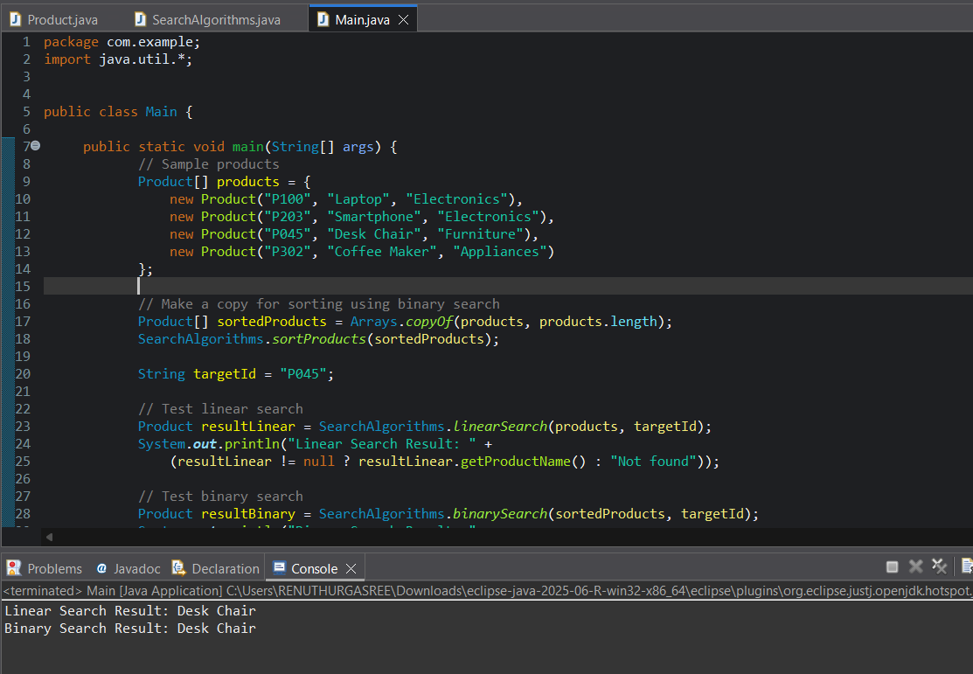

Analysis:

Time Complexity comparison:
Scenario | Linear Search | Binary Search
Best case | O(1) - First element | O(1) - Middle element
Average case | O(n) | O(log n)
Worst case | O(n) | O(log n)

Suitable Algorithm:
Binary search will be more suitable for an E-commerce Search Function. As it works well for large , static product catalogs that can be sorted by productId.

